Step 1: copy framework to your project finder

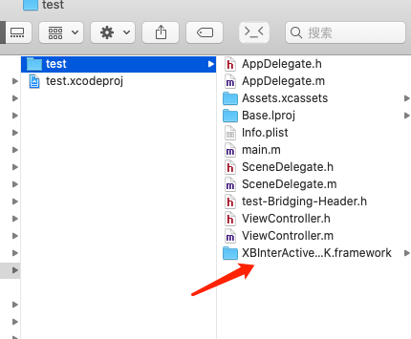

Step 2: add files -> .framework

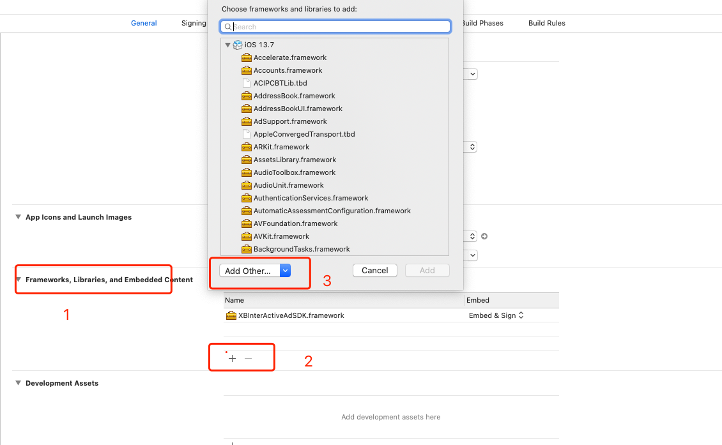

Step 3: use framework like this

